ART GALLERY WEBSITE
@CREATIVITY THINK (9483175986/7019689991)

ABSTRACT:
Art Gallery Website is a web application designed to provide an interactive platform for showcasing artworks and managing art exhibitions. Users can browse artwork listings, explore artist profiles, comment and rate pieces, schedule visits, and access dashboards. Administrators can add or edit artworks, manage artist profiles and exhibitions, and monitor analytics dashboards. The backend uses Django and Django Rest Framework for secure data handling and business logic, while React, Axios, and Recharts power the frontend for responsive interfaces and interactive dashboards. This platform enhances visitor engagement and streamlines art gallery management..

INTRODUCTION OF THE PROJECT:
Modern art galleries require efficient digital platforms to showcase artworks, manage exhibitions, and engage visitors online. Art Gallery Website allows users to explore artwork listings, artist profiles, provide ratings and comments, and schedule gallery visits. Administrators can manage artworks, artist profiles, exhibitions, and track analytics. The system leverages Django and Django Rest Framework for backend services and React with Recharts for interactive dashboards. This web application simplifies art collection management while enhancing user engagement and educational accessibility..

PROJECT OBJECTIVES:

• Provide users with detailed artwork listings and artist profiles
• Enable commenting and rating on artworks for visitor engagement
• Allow scheduling of gallery visits
• Enable administrators to add/edit artworks and manage exhibitions
• Provide analytics dashboards for performance and visitor insights
• Streamline gallery management for museums and artists
• Facilitate educational access to art collections

PROBLEM OF THE STATEMENT:
Art galleries face challenges in managing collections, exhibitions, and visitor engagement digitally. Users often lack accessible platforms to explore artworks and interact with artists, while administrators struggle with manual management of exhibitions, artworks, and analytics. The Art Gallery Website addresses these issues by providing a web-based solution for artwork browsing, ratings, scheduling visits, and interactive dashboards, offering both an engaging user experience and streamlined administrative management..

MOTIVATION OF THE PROJECT:
• Enhance accessibility to art collections for users
• Promote interactive engagement through comments and ratings
• Facilitate scheduling and management of gallery visits
• Provide administrators with comprehensive dashboards for decision-making
• Streamline online management of artworks, artists, and exhibitions

BLOCK DAIGRAM OF PROJECT:

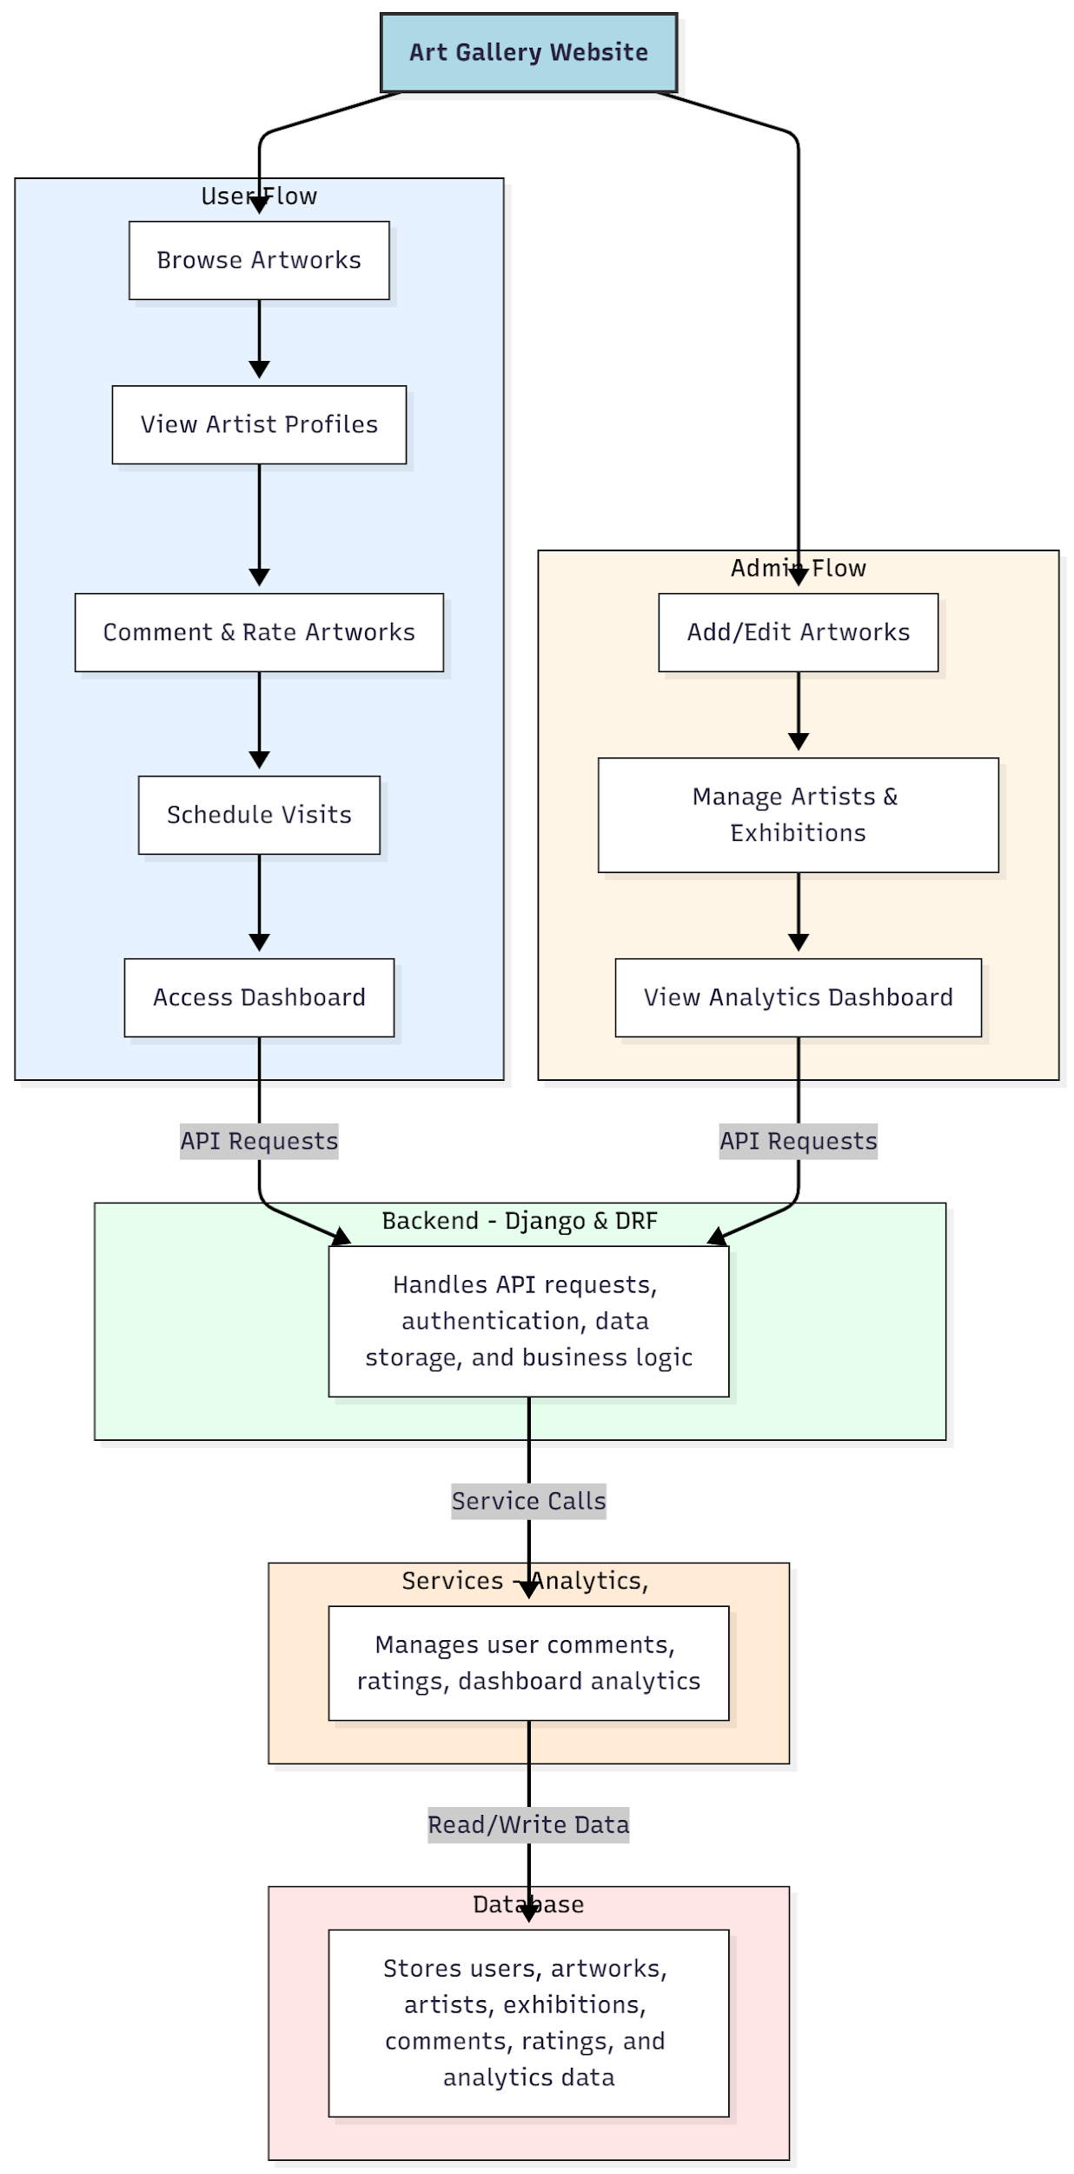

WORKING OF THE PROJECT:
Users browse artworks, view artist profiles, comment and rate pieces, schedule gallery visits, and access dashboards. The backend handles API requests, authentication, data storage, and business logic. Services manage feedback, ratings, and analytics dashboards. Administrators add or edit artworks, manage artist profiles and exhibitions, and monitor analytics dashboards. This setup ensures efficient art collection management, interactive visitor engagement, and comprehensive oversight for administrators..

SOFTWARE REQUIREMENT:
- Backend:
  - Python 3.x
  - Django
  - Django REST Framework
  - SQLite/PostgreSQL
- Frontend:
  - Node.js and npm
  - React.js
  - Axios
- Development Tools:
  - Visual Studio Code
  - Postman (for testing APIs)
  - Git/GitHub (for version control)
- Server/Deployment (Optional):
  - Gunicorn, Nginx, or Heroku/AWS for hosting

ADVANTAGES OF THE PROJECT:

• Interactive browsing of artworks for users
• Access to detailed artist profiles
• User engagement through comments and ratings
• Scheduling of gallery visits
• Analytics dashboards for administrators
• Streamlined management of artworks and exhibitions
• Improved educational accessibility to art collections
• Centralized platform for both users and administrators

APPLICATIONS OF THE PROJECT:
• Museums and art galleries online showcases
• Artist portfolio and exhibition management
• Educational platforms for art studies
• Visitor engagement through comments and ratings
• Scheduling and management of gallery visits
• Analytics dashboards for gallery administrators
• Centralized digital art collections management
• Feedback-driven enhancement of art exhibitions

REFERENCES:

- Django REST Framework Documentation — Django Software Foundation. Django Documentation. Available: https://docs.djangoproject.com/
- Django REST Framework. DRF Documentation. Available: https://www.django-rest-framework.org/
- React. React Official Documentation. Available: https://reactjs.org/docs/getting-started.html
- Redux. Redux Documentation. Available: https://redux.js.org/introduction/getting-started
- PostgreSQL Global Development Group. PostgreSQL Documentation. Available: https://www.postgresql.org/docs/
- MySQL. MySQL Reference Manual. Available: https://dev.mysql.com/doc/
- Git. Git Documentation. Available: https://git-scm.com/doc
- Node.js. Node.js Documentation. Available: https://nodejs.org/en/docs/
- Axios. Axios Documentation. Available: https://axios-http.com/docs/intro
- Socket.io Documentation – https://socket.io/docs/

